**Task 1:**

#include<iostream>

using namespace std;

class A

{

public:

A()

{

cout << "This is constructor of class A" << endl;

}

~A()

{

cout << "This is destructor of class A" << endl;

}

};

class B :public A

{

public:

B()

{

cout << "THis is constructor of class B" << endl;

}

~B()

{

cout << "This is destructor of class B" << endl;

}

};

class C :public B

{

public:

C()

{

cout << "This is constructor of class C" << endl;

}

~C()

{

cout << "This is destructor of class C"<<endl;

}

};

int main()

{

C obj;

system("pause");

}

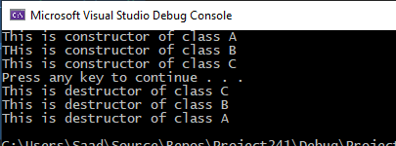

**Task 2:**

#include<iostream>

using namespace std;

class student

{

private:

int number;

string name;

double average;

public:

student()

{

number = 0;

name = " ";

average = 0;

}

void setNumber(int a)

{

number = a;

}

int getNumber()

{

return number;

}

void setName(string b)

{

name = b;

}

string getName()

{

return name;

}

void setAverage(double a)

{

average = a;

}

double getAverage()

{

return average;

}

void input()

{

cout << "Enter the number of student :";

cin >> number;

cout << "Enter the name of student :";

cin >> name;

cout << "Enter the average of student :";

cin >> average;

}

void display()

{

cout << "The number of student " << number << endl;

cout << "The name of student " << name << endl;

cout << "The average of student " << average << endl;

}

};

class graduate_year :public student

{

private:

int level;

int year;

public:

graduate_year() :student()

{

level = 0;

year = 0;

}

void setLevel(int a)

{

level = a;

}

int getLevel()

{

return level;

}

void setYear(int b)

{

year = b;

}

int getyear()

{

return year;

}

void input()

{

student::input();

cout << "Enter level of the garaduate student :";

cin >> level;

cout << "Enter year of the garaduate student :";

cin >> year;

}

void display()

{

student::display();

cout << "The Level of the graduate student is " << level<<endl;

cout << "The year of the graduate student is " << year << endl;

}

};

class master:public graduate_year

{

private:

int newid;

public:

master():graduate_year()

{

newid = 0;

}

void setNewid(int a)

{

newid = a;

}

int getNewid()

{

return newid;

}

void input()

{

graduate_year::input();

cout << "Enter the new id :";

cin >> newid;

}

void display()

{

graduate_year::display();

cout << "The new id is " << newid<<endl;

}

};

int main()

{

student obj;

master obj1;

obj.input();

obj.display();

obj1.input();

obj1.display();

}

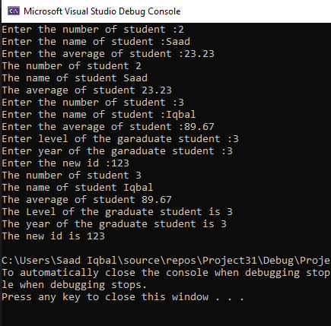

**Task 3:**

#include<iostream>

using namespace std;

class mammals

{

public:

void display()

{

cout << "I am mammal"<<endl;

}

};

class marinemammals

{

public:

void display1()

{

cout << "I am marine mammal" << endl;

}

};

class bluewhale :public mammals,public marinemammals

{

public:

void display2()

{

cout << "I am blue whale" << endl;

}

};

int main()

{

mammals obj;

marinemammals obj1;

bluewhale obj2;

obj.display();

obj1.display1();

obj2.display2();

obj2.display();

obj2.display1();

}

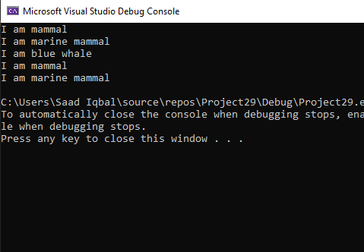

**Task 4:**

#include<iostream>

using namespace std;

class musicians

{

public:

musicians()

{

}

void String()

{

string array1[] = { "veena", "guitar", "sitar", "sarod" ,"mandolin" };

cout << "The instruments of the String are :" << endl;

for (int i = 0; i < 5; i++)

{

cout << array1[i]<<endl;

}

}

void wind()

{

string array2[] = { "flute", "clarinet ","saxophone", "nadhaswaram"," piccolo" };

cout << "The instruments of the wind are :" << endl;

for (int i = 0; i < 5; i++)

{

cout << array2[i]<<endl;

}

}

void perc()

{

string array3[] = { "tabla", "mridangam", "bangos", "drums" , "tambour" };

cout<< "The instruments of the perc are :"<<endl;

for (int i = 0; i < 5; i++)

{

cout << array3[i]<<endl;

}

}

};

class TypeIns:public musicians

{

public:

void get()

{

String();

wind();

perc();

}

void show()

{

cout << "Enter 1 for string instruments"<<endl;

cout << "Enter 2 for wind instruments" << endl;

cout << "Enter 3 for perc instruments" << endl;

int a;

a:cin >> a;

if (a == 1)

{

String();

}

else if (a == 2)

{

wind();

}

else if (a == 3)

{

perc();

}

else

{

cout << "Enter number again";

goto a;

}

}

};

int main()

{

TypeIns a;

a.get();

a.show();

}

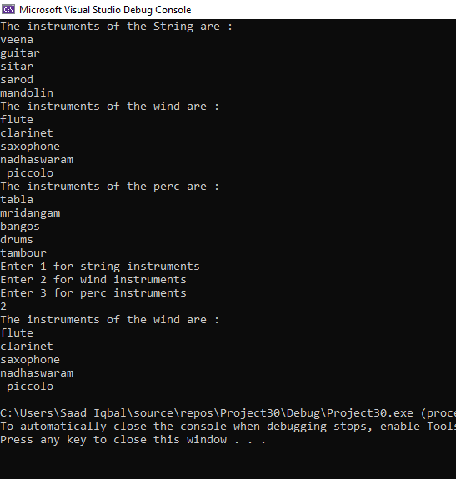

**Task 5:**

#include<iostream>

#include<string>

using namespace std;

class persondata

{

private:

string fname;

string lname;

string address;

string city;

string state;

public:

persondata()

{

fname = " ";

lname = " ";

address = " ";

city = " ";

state = " ";

}

void setFname(string n)

{

fname = n;

}

string getFname()

{

return fname;

}

void setLname(string n)

{

lname = n;

}

string getLname()

{

return lname;

}

void setAddress(string n)

{

address = n;

}

string getAddress()

{

return address;

}

void setCity(string n)

{

city = n;

}

string getCity()

{

return city;

}

void setState(string n)

{

state = n;

}

string getState()

{

return state;

}

void input()

{

cout << "Enter the first name of the person :";

getline(cin, fname);

cout << "Enter the last name of the person :";

getline(cin, lname);

cout << "Enter the address of the person :";

getline(cin, address);

cout << "Enter the city of the person :";

getline(cin, city);

cout << "Enter the state of the person :";

getline(cin, state);

}

void display()

{

cout << "The first name of the person is " << fname<<endl;

cout << "The last name of the person is " << lname << endl;

cout << "The address of the person is " << address << endl;

cout << "The city of the person is " << city << endl;

cout << "The state of the person is " << state << endl;

}

};

class customerdata:public persondata

{

private:

int customernumber;

bool mailinglist;

public:

customerdata():persondata()

{

customernumber = 0;

mailinglist = false;

}

void setCustomernumber(int a)

{

customernumber = a;

}

int getCustomernumber()

{

return customernumber;

}

void setMailinglist(bool a)

{

mailinglist = a;

}

bool getMailinglist()

{

return mailinglist;

}

void input()

{

persondata::input();

cout << "Enter customer id :";

cin >> customernumber;

cout << "Enter mailinglist :";

cin >> mailinglist;

}

void display()

{

persondata::display();

cout << "The customer id is :" << customernumber<<endl;

cout << "The mailinglist is :" << mailinglist<<endl;

}

};

int main()

{

customerdata obj;

obj.input();

obj.display();

}

